**BARHAM PRIMARY SCHOOL - EQUALITY OBJECTIVES**

**2019-2020**

|  |  |
| --- | --- |
| **Our Equality Objectives**  **Reviewed September 2019** | |
| The Equality Act 2010 requires us to publish specific and measurable equality objectives. Our equality objectives are based on our analysis of data and other information. Our equality objectives focus on those areas where we have agreed to take action to improve equality and tackle disadvantages. | |
| **Objective 1:** | **The equality objectives will be monitored:** |
| To include all in our Rights Respecting Agenda; pupils, families, staff and the wider community.  To aim for a culture of ‘No Outsiders’ where all are of equal value whatever their ethnicity, race, culture, disability, religion, sexual orientation, gender, gender identity, economic circumstance or legal status is. | -Pupil voice  -Pupil survey  -Parent groups/classes/ surveys/ forums  -Open door policy  -Parent view  -Community feedback  -Curriculum Sampling/ moderations |
| **Objective 2:** | **The equality objectives will be monitored:** |
| To enhance the proficiency of spoken language for our in year joiners that have English as an additional language through quality first teaching by tracking to ensure they meet or exceed end of year expectations. (Strategic priority 2) | **Actions:**  *- Investigate the causes of pupil mobility within the school  - Examine the cause of mobility in schools in the context of mobile groups. - Explore challenges for managing mobility - Develop strategies to address pupil mobility by enhancing the existing good practice and providing further bespoke provision to address the barriers to accessing the English language* through:  Reviewing and further supporting the induction, assessment and monitoring of newly arrived pupils in the school and effective use of data for self‐evaluation.  **Outcomes:**  *- Confident EAL learner speakers who are able to articulate their understanding across the curriculum by using fluent, more varied and complex speech in a wider range of context*  *-Raised attainment for expected and greater depth in spoken language across the school demonstrating higher order receptive and expressive language*  -Children articulate their learning effectively using topic specific technical vocabulary within lessons and to the wider school community (senior leaders, visitors, governors).  -Evidence of progress and increased attainment in speaking and listening through termly summative assessment data.  -Pupil Interviews will further demonstrate progress within pupils speaking abilities through higher quality responses.  -Lesson observations and Learning Walks show teachers and support staff modelling and explaining ambitious and technical vocabulary.  -Children within the debate society demonstrate and model their learning to wider school community through assemblies and competitions. |
| **Objective 3:** | **The equality objectives will be monitored:** |
| To ensure that girls from around the world improve their lives through education. They are assertive active learners and are empowered to do so. They participate, progress and attain more throughout the whole curriculum. (Strategic priority 5) | **Actions:**  -challenge stereotypes and raise aspirations  -identify girls who don’t engage in the same way as their peers  -monitor behaviours (invisible in the classroom? Putting hands up half way up?)  -target questions  -respond to children’s ‘responses’  -challenge and probe  **Outcomes:**  -qualitative measure: changes in behaviour and engagement  -quantitative measure: Dec 2018; Dec 2019; July 2010 |

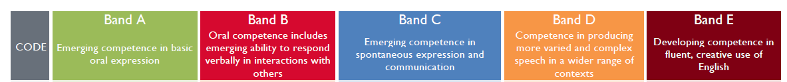*Objective 2:*