Barham Primary
Health & Safety

HEALTH & SAFETY POLICY FOR BARHAM PRIMARY SCHOOL

Danethorpe Road
Wembley
HA0 4RQ
Tel:0208-902-3706

XXXXX 2000 (n Edition)

Revised September 2015

Barham Primary School 2014

Barham Primary
Health & Safety
CONTENTS

 | Statement by Chair of Governing Body
Part 1 | Managing Health and Safety Local Policy Statement
Part 2 | The Organisation and responsibilities for implementing health and safety within Schools
Part 3 | The arrangements for carrying out health and safety within Schools
Part 4 | Useful addresses and contact numbers
Appendix

A | Management structure for health and safety
B | Duties and responsibilities: Governors
C | Duties and responsibilities: the Head Teacher
D | Duties and responsibilities: Staff
E | Duties and responsibilities: Visitors & Contractors

Revised Date 21st September 2015

Signed Chair of Governors :

Signed Chair of Building and Finance Committee:
:

Statement by the Chair of the Governing Body

The delegation of funding to schools has meant that although the local education authority (LEA) remains the employer and therefore ultimately responsible for health and safety, there are many areas for which the Governing Body has a delegated responsibility, and a number of these are summarised in Appendix A to H of this guidance.

As Chair of the Governing Body, I accept, on behalf of all of the Governors, responsibility for those areas listed in Appendix B, and confirm that everything reasonably practicable will be done to protect the health, safety and welfare of staff, pupils, visitors, contractors and all others working on or visiting the site.

To help the Governors achieve this objective, the Head Teacher has the day-to-day responsibility for health and safety matters within their school. To this end the Head
Teacher is also responsible for seeing that the LEA’s safety guidance, The Council’s Corporate Health and Safety Policy and other relevant guidance, are properly implemented and enforced. In addition, any matters of concern are brought to the attention of the Governors as quickly as possible.

Copies of this policy statement will be made available to all members of staff and displayed on Health & Safety notice board located in the Staffroom.
Copies of relevant guidance and other health and safety information will be held in the Facilities Managers office and made readily available to all members of staff to refer to.

Signed Chair of governing Body :

D.Thanki

Chair of the Governing Body
(Daksha Thanki)

Date:

Safety Audit

To reduce risks to staff, pupils and visitors while on site and to help us maintain a safe environment, we are advised by the Health, Safety & Licensing Department of Brent Council who also carry out biannual safety audit of premises. This enables us to make sure we keep up to date with current safety regulations and maintain legal requirements. Below is a copy of the Certificate of Inspection. A full copy of this report is available on request from the Head Teacher/Facilities Manager.

Next Inspection/Audit : Due 17 September 2016
Health Safety & Licensing can be contacted on 020 8937 1234 or e-mail : hsl@brent.gov.uk
Web site: www.brent.gov.uk/hsl

Last inspection
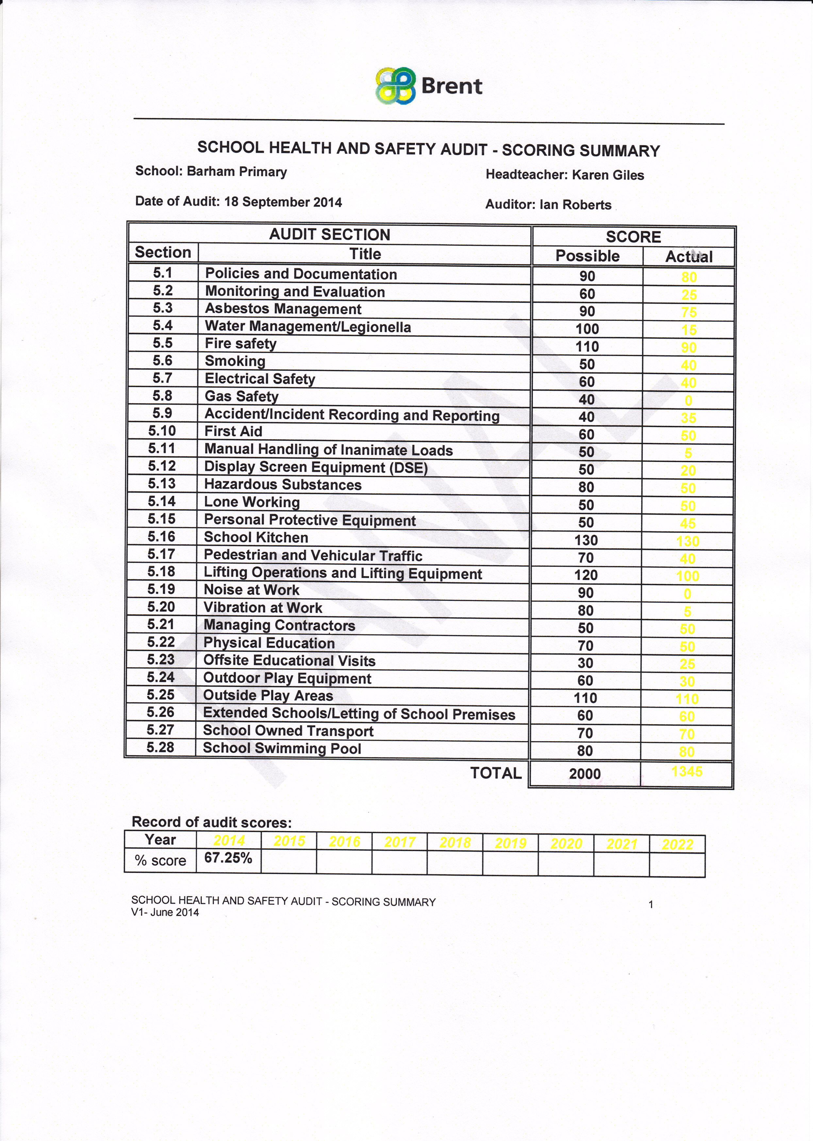

PART 1

1.1 LOCAL POLICY STATEMENT

1.2 This Health and Safety Policy Statement deals with the aspects of health, safety and welfare over which the Head Teacher and Governors have control. This control is not limited to matters funded from the school’s delegated budget or otherwise under the direction of the Governors, but rather extends to cover everything associated with the site as a whole, including those matters for which other officers of the Council also have a responsibility.

1.3 This policy statement is written specifically for the benefit of staff and pupils at Barham School. It is intended to supplement rather than replace the Corporate Health and Safety Policy statement and the local education authority (LEA) commitment to managing health and safety within schools. Those statements remain in force and provide the overall standards and structure that the school will continue to follow. Copies of these documents along with relevant guidance and other information on health and safety matters will be kept in the Facilities Managers office and are readily available for all staff to refer to.

1.4 The continuing policy of this school is to conduct its operations in such a manner as will ensure, as far as reasonably practicable, the health, safety and welfare at work of staff, pupils and others on the site.

1.5 All staff have an important part to play in implementing the policy. In particular, they have a duty to take reasonable care for the safety of themselves and anyone else that may be affected by what they do or fail to do. Staff also have a responsibility to co-operate with others in the interests of health and safety.

1.6 The Head Teacher and Governors, in seeking to ensure that everything reasonably practicable is done to safeguard the health, safety and welfare of all those using the site, will:
- Ensure the safeguarding and CRB procedures are undertaken as per instruction by local government and education department .
- Establish and maintain a safe and healthy place of work for pupils, staff and others
- Provide information, instruction and supervision so that staff and pupils can work safely, avoiding hazards to themselves and others
- Set up effective procedures to be used in cases of fire and other emergencies which involve evacuating the building
- Set up procedures to be followed in the event of an accident
- Provide adequate welfare facilities.

1.7 This policy statement will be reviewed every year and revised as and when necessary.

PART 2

2.0 THE ORGANISATION AND RESPONSIBILITIES FOR IMPLEMENTING HEALTH AND SAFETY IN BARHAM PRIMARY SCHOOL

2.1 Management

2.1.1 The overall management structure for dealing with health and safety matters is shown in Appendix A. The responsibilities of Governors, the Headteacher and members of staff are listed in Appendix B.

2.2 Members of staff holding positions of responsibility

2.2.1 All members of staff with a responsibility for others have a duty to implement this policy as far as they are able and to bring to the attention of the Headteacher any concerns affecting the health, safety and welfare of those for whom they are responsible.

2.3 All staff

2.3.1 All staff must take reasonable care of their own health, safety and welfare and have a duty to avoid doing anything likely to endanger themselves or others.

2.3.2 They must also use any equipment and follow any procedure set to ensure their health, safety and welfare.

2.4 The local education authority (LEA)

2.4.1 The Director of Education will arrange for the Council’s Health, Safety and Licensing (HSL) Unit to provide any specialist advice and guidance required on any health and safety matters relevant to schools. HSL will also advise on health and safety training needs of members of staff.

2.5 School health and safety committee

2.5.1 A health and safety committee (membership to include the trade union health and safety representative and/or any safety representatives selected by the staff) will be set up within the school for staff to raise concerns, suggestions for improvements etc.

2.5.2 The committee will meet once a term but health and safety issues can be raised at any time with the Head or the Trade Union Health and Safety representative. Health and safety matters are also dealt with in staff meetings and training days.

2.6 The Corporate Health and Safety Committee

2.6.1 The Corporate Health and Safety Committee meets once every quarter to consider health and safety matters and issues affecting Council services as a whole including schools. Trade unions and professional associations are represented at this Committee

2.6.2 Minutes of the meeting are circulated to members and are also available directly from HSL or on the Council’s Intranet.

PART 3

3.0 THE ARRANGEMENTS FOR CARRYING OUT HEALTH AND SAFETY WITHIN SCHOOLS

3.1 Accident and Incident Reporting

    - All accidents and incidents no matter how trivial they may seem at the time will be recorded in the appropriate accident or incident book. Accident Books (Staff, Pupil records) located in Welfare room (Pupil Only) Located in Nursery.

    - All accidents that are reportable must be reported using the Brent Council internal Accident and Incident Report Form. A copy of the relevant form can be found in the Corporate Safety Guidance on Accident and Incident Reporting. Reportable accidents and incidents will be notified to HSL within five working days. HSL will undertake the statutory function of notification to the Health and Safety Executive (HSE) of all reportable accidents and incidents notified by the School.

    - All accidents and incidents that occur will require an investigation by the Headteacher or responsible person to ensure that a recurrence is prevented and that adequate control measures are in place.

    - The Corporate Guidance on Accident and Incident Reporting will be available in the Facilities Managers office and can also be obtained from HSL or the Council’s Intranet.

3.2 Health and Safety Advice and Assistance

3.2.1 Staff seeking advice on safety issues including the need to resolve a health and safety matter within the School, should in the first instance contact the Headteacher and where relevant their Trade Union Health and Safety representative.

3.2.2 If the matter cannot be resolved locally, or further advice is deemed necessary in relation to requirements of legislation the Head Teacher/Facilities Manager or the member of staff should contact HSL.

3.3 Children with special needs

3.3.1 The school has put into place policies for meeting the needs of children with asthma, severe allergic reaction, etc. based on advice provided by the LEA and HSL where applicable.

3.4 Contractors

    - All forms of maintenance and construction work on site will be monitored by the Facilities Manager/ Premises Staff to ensure that it is carried out without risk to staff, pupils and others. The Head Teacher will be informed immediately of any cause for concern and the appropriate action will be taken.

    - Contractors will be required to submit relevant risk and other assessments including a detailed method statement specifying how the work will be done safely, before works are allowed to commence.

    - All contractors appointed by the Governing Body and school will be required to abide by the Councils Corporate Technical Standard for Contractors. A copy is available from the Facilities Managers office and also obtainable from HSL or on the Council’s Intranet.

  - Curriculum & Pupil Care

    - The safety of pupils in classrooms is the responsibility of class teachers. Teachers have traditionally carried this responsibility for the safety of pupils when in their charge.

    - Ensure the safeguarding and CRB procedures are undertaken for all staff working with Children and ensure that any staff still awaiting necessary paperwork are not left unaccompanied at any time with children .

    - If for any reason (e.g. that condition or location of equipment, the physical state of the room or the arrangement of a class for practical work) a teacher considers she/he cannot accept this responsibility, she/he should discuss the matter with the Head teacher before allowing practical work to take place.

3.5.4 Health and safety in specific subject areas will be based upon the advice provided by the LEA in codes of practice on, for example, science and art and design. Copies of these codes including other relevant guidance are available from the Head teachers office,

Class teachers are expected :

- to exercise effective supervision of the pupils and to know the emergency procedures in respect of fire, bomb scare and first aid and to carry them out

- to know the special safety measures to be adopted in their own special teaching areas and to ensure that they are applied.

- to give clear instructions and warning as often as necessary.

- to follow safe working procedures personally, ie use of kick-small ladders or library kick steps (provided) should be used where staff need to reach above their normal stretch e.g. staff should not stand on chairs or tables for any reason when putting up or taking down displays.

- to call for protective clothing, guards, special safe working procedures, etc. where necessary. Removing staples – purpose made staple removers should be used for removing staples from display boards. All staples should be removed each time a display is taken down as these can present a hazard.

- to make recommendations to the Head or Deputy as to necessary safety equipment, additions or improvements to plant, tools, equipment or machinery which may be dangerous.

3.5.5 Supervision of pupils

- the movement of children between different parts of the building school trips including staff/pupil ratios, insurance, supervision/transport of pupils to sports events etc (supervision of pupils on the journey)

- Supervision of children –
Note : Under no circumstances or at any time should any child be in the school building unsupervised. Where staff wish children to be in at break times they should collect them from one of the school entrances. Children should not be left outside the staffroom unsupervised. Children should not stand on chairs or tables for any reason.

- Playground duties
Note : Hot drinks – these should not be carried around the school site while children are present. This includes those staff on playground duty who should have cold drinks. This ensures that no child or member of staff risks being scalded by hot drinks should the drink be knocked from their hand.

- Pupils taking medicines as part of a course of treatment – see Medicine policy.

3.6 Display screen equipment (DSE)

3.6.6 DSE will be provided and used in accordance with the Councils Technical Standard for the Safe Use of DSE. DSE must meet the requirements of the Health and Safety (Display Screen Equipment) Regulations 1992. A copy of the technical standard is kept in the Facilities Managers office and is also obtainable from HSL or on the Council’s Intranet.

3.7 Administration of Medication

3.7.1 Administration of prescribed and non-prescribed medication will be controlled and administered in accordance with the Councils Corporate Safety Guidance on the Administration of Medication. A copy of which is kept in the Headteachers office and is also obtainable from HSL or on the Council’s Intranet

3.8 Electricity

3.8.1 All portable electrical equipment used at the school must meet the relevant British Standard and will be inspected and tested as required by the Electricity at Work Regulations and in line with the Corporate Safety Guidance on Portable Appliances Testing and Fixed Installations. The guidance is available in the school office and also obtainable from HSL or on the Council’s Intranet. The school will keep records of all tests carried out on items of electrical equipment including fixed electrical installations.

3.8.2 Any item of electrical equipment found to be defective will be removed from use immediately as long as it is safe to do so. A safety warning sign must be attached stating that the equipment is out of use/do not use until it has been repaired and re-tested by a competent person or replaced.

3.8.3 Staff are encouraged to make daily visual inspections each time they use an item of electrical equipment so that any defects can be quickly found and dealt with.

3.8.4 The School will have a full electrical inspection undertaken by a competent person at least once every five years. Last Test Date July 2014 (see APPENDIX G Fixed Wiring test finding.)

3.9 Equipment including Playground equipment.

    - PE equipment will be tested annually by a specialist contractor. Staff supervising PE & play activities involving the use of equipment and playground equipment are required to carry out a brief visual inspection of the equipment each time before it is used.

    - The Premises Staff will visually inspect playground equipment on a regular basis. At intervals of between one and three months a more detailed inspection should be undertaken and the results entered into a permanent record. Particular attention should be paid to the effects of corrosion or other deterioration, wear and vandalism, all of which will be particular to individual locations.

    - Certificated inspection of play equipment to be carried out yearly. A competent engineer must carry out this inspection and the results of the inspection entered on a permanent record.

    - Any defects found in any equipment will be reported for urgent repair and the equipment will be withdrawn from use until made safe.

    - Play equipment used externally must be mounted on a suitable safety absorbent impact surface that complies with the appropriate British and European Standards. Play Equipment and toys must be fit for use of play and meet British and European Standards, Staff supervising play should ensure that standards for play equipment are met at all times

    - Children are supervised during lunch and at break times by teaching staff. At lunchtimes this duty is undertaken by Teaching Assistants (playground) and Dining hall Assistants in the canteen , supported as necessary by members of the teaching staff.

    - Allotment Area

3.9.8 Due to the location and nature of the wild area all staff must, before using this important resource, become familiar with the emergency procedures for this part of the school. Pupils should be reminded of the dangers of water and fires (especially in dry weather in grass areas). They should also be advised about the action to take should the teacher have an accident

3.9.9 All staff must ensure that a ratio of not more that 30:1 is maintained at all times i.e. not more than 30 children per teacher.

3.9.10 Deleted due to removal of pond.

3.9.11 The number of pupils entering and exiting the area must be noted and all accounted for on leaving. .

3.9.12 Deleted

3.9.13 Emergency procedure for allotment area

3.9.14 If an emergency happens within the wild area the teacher will remain with the pupil/pupils at all times.

3.9.15 Two responsible pupils will be sent to the main school/head teacher’s office with clear instructions as to where and what appears to have happened. Pupils will remain at the office until being accompanied back to wild area with first aider/helpers.

3.9.16 Deleted

3.9.17 All accidents must be recorded in the accident book (held in the welfare room)

3.10 Fire precautions

    - The school has drawn up an emergency plan to meet the requirements of the Fire Precautions (Places of Work) Regulations 1997.

    - All staff will be made aware of the emergency plan including the action to be taken in the event of a fire. A full evacuation/practice drill will be carried out each term (at 3 drills per year) at a time to be decided by the Head teacher, details of the evacuation will be recorded in the Fire Certificate logbook.

    - The Fire Certificate Logbook will provide details of weekly checks of the fire alarm and other fire precaution equipment, as well as fire drills and staff training. A copy of the fire certificate logbook will be kept in the Facilities Manager Office .

    - Note that the school has a No Smoking Policy and therefore smoking is not tolerated on any part of the school site. Persons found smoking on council premises can also be disciplined under the council’s disciplinary code and procedures.

3.10.5 The School’s emergency plan complies with the Council’s Technical Standards for Fire and Emergency Evacuation, a copy of which is kept in the Facilities Manager Office and can also be obtained from HSL or on the Council’s Intranet.

3.11 Fire extinguishers

    - Staff expected to use fire extinguishers will be given training, although in the event of a fire the first priority must be given to escorting children and other members of staff safely from the building.

    - The Premises staff will carry out daily visual inspections of the extinguishers to ensure that they are in good order, and will report any defect to the Facilities Manager/ Head Teacher immediately. Arrangements will be made for any necessary maintenance to be carried out as quickly as possible.

    - Fire extinguishers will be serviced annually by a competent person.

Next Test Date January 2016 (See APPENDIX H)

3.12 Fire evacuation notices

    - Fire Action Notices giving details of the nearest fire exit are displayed throughout the school. The notices are completed and inform staff and other persons using the building of the action to take in the event of a fire or emergency. Classroom staff must ensure that Fire Action Notices are kept clear and free from obstruction at all times.

    - Staff must use the nearest available exit and assemble the children at the pre-determined fire assembly points as quickly as possible.

3.13 Fire doors and fire exits

3.13.1 Fire doors will be kept in a closed position and not propped open. Vision panels on fire doors and fire exits must be kept clear at all times.

3.13.2 All fire doors and fire exits will be suitably signed clear of posters and flyers and remain unlocked while the school is occupied.

3.13.3 All fire escape routes will remain free of furniture and combustible materials.

3.14 First aid/welfare

3.14.1 The Welfare Assistant has delegated responsibility for health care within the School. The school aims to have at least one other member of staff trained to provide first aid assistance in the absence of the Welfare Assistant. (see APPENDIX F trained first aiders).

3.14.2 First aid provisions within the School will comply with the Council’s Corporate Safety Guidance on First Aid at Work. A copy of the guidance is kept in the Facilities Managers office and can also be obtained from HSL or on the Council’s Intranet.

3.15 Hazardous substances

    - All chemicals and other products known to be hazardous, and any processes that create dust or fumes will be assessed in accordance with the Control of Substances Hazardous to Health (COSHH) Regulations. The assessment must be recorded.

    - The school will ensure that written information on the correct use and storage of each product is made available to the staff concerned including a copy of the relevant and current safety data sheet.

    - Whenever possible, substances that are classed as hazardous will be replaced with safer alternatives. The School will keep an up to date inventory of all hazardous substances and products stored on site.

    - The Council’s Technical Standard on COSHH & Undertaking COSHH Assessments provides further detailed advice and information on hazards associated with the use of hazardous substances and processes. A copy is available in the Facilities Managers office and can also be obtained from HSL.

3.16 Induction

3.16.1 The induction process for all new staff will include training and instruction in the school’s health and safety policies and relevant procedures including fire safety.
3.17 Lettings/Extended School Partners

    - The responsibility for letting/Extended School Partners the school premises to a third party for a celebration, including fetes, fun days, etc rests with the Head Teacher/responsible person.

    - HSL recommend that schools undertake a specific risk assessment for all types of lettings/Extended Schools that are permitted. The risk assessment must be brought to the attention of the person(s) hiring and using the premises. The Headteacher should also ensure that they have obtained the following documentation before a letting/ extended schools is permitted:

- copy of third parties public liability insurance
- copies of risk assessments (that details how the celebration etc will be managed safely)
- current test certificates to verify that any electrical equipment, machinery, fairground rides, bouncy castles brought on to the premises by a third party have been tested by a competent person and are safe and in good condition.

    - In addition the School will have a written contract with the persons hiring/using the premises. This contract will include health and safety matters that need to be in place and who is directly responsible for managing health and safety for the duration of the event, celebration etc.

3.18 Manual handling
3.18.1 The Council’s Corporate Guidance on Manual Handling Operations will be followed to make sure that every precaution is taken to prevent injury to staff and children who may be asked to lift items of PE or other equipment at school.

3.18.2 A copy of the guidance is available from the school office and is also obtainable from HSL and on the Council’s Intranet.

3.18.3 Children and staff will not be required to lift anything beyond their capabilities.
3.18.4 Manual handling assessments will be undertaken for hazardous lifting tasks.

3.19 Minibus & Coaches

3.19.1 Any minibus owned or hired by the school will be driven and maintained in line with the requirements of legislation and the Highway Code. Seat belts will be provided and worn at all times when the minibus is in use.

3.19.2 The appropriate insurance, road tax, current MOT, Driver permits are available. The minibus driver and other persons in charge of children will not be under the influence of alcohol or other substances.

3.20 Risk assessments

    - As required by the Management of Health and Safety at Work Regulations 1999, risk assessments will be undertaken to identify any risks to employees and others resulting from work activities or processes.

    - When significant risks are identified the assessment will be recorded in writing using the Council’s Corporate Risk Assessment Form and relevant guidance.

    - Everything reasonably practicable will be done to minimise or remove the risks, and written assessments will be reviewed at least annually unless stated otherwise.

    - Where appropriate, the Head teacher will arrange for training to be provided on undertaking risk assessments. HSL can provide schools with copies of generic risk assessments. However the onus is on the Head teacher to ensure that these assessments are tailored to adequately address specific hazards and risks within the school.

    - The Council’s Corporate Guidance on Managing Safety and Undertaking Risk Assessments will be referred to for further advice and information. A copy of the guidance will be made available in the Facilities Manager Office and is also obtainable from HSL and on the Council’s Intranet.

3.21 Exposure to the sun

3.21.1 Care will be taken to protect children and staff from prolonged exposure to the sun on very hot days. Shade and drinking water will be made available. Children will be required to wear a sun protection factor of a minimum factor 15. Children should also be encouraged to wear suitable head protection during very hot weather.

3.21.2 The Council’s Technical Standard on Working in Hot and Cold Temperatures will be referred to for further advice and information. A copy of the standard will be available in the Facilities Manager Office and is also obtainable from HSL and on the Council’s Intranet.

3.22 Off Site Activities

    - Before off site activities are arranged the following will be undertaken:

- Written consent will be obtained from the parent/guardian
- A risk assessment will be undertaken to ensure that adequate control measures are in place to prevent or eliminate as far as is reasonably practicable risks to children and other persons.
- The risk assessment will also identify the number of staff required to supervise and monitor the activities
- Where relevant the Head Teacher or responsible person will visit the venue, premises etc to ensure that it is suitable for the age group intended and that adequate health and safety precautions have been put in place.
- Adequate first aid and emergency arrangements will be put in place.
- All activities will be arranged in line with the curriculum, DFEE advice and guidance and in accordance with the LEA’s terms and conditions.

3.22.2 All visits will be organised in accordance with the Corporate Safety Guidance on Off-Site Activities. A copy of the guidance is available from the Facilities Manager Office and can be obtained from HSL and on the Council’s Intranet.

3.23 Health and Safety training

3.23.1 All members of staff will be required to undertake health and safety training relevant to their working environment and in line with the tasks and activities they are required to undertake.

3.23.2 Training can be arranged through or undertaken by HSL. Training records should be kept with copies placed on the employees’ personal file.

3.23.3 Health and safety training for School staff is considered a priority by the Governing Body and has its full support.

3.24 Vehicles on the school premises

3.24.1 Signs showing the maximum speed limit are prominently displayed. The necessary, action will be taken to enforce the speed limit.

3.24.2 Deliveries will, whenever possible, be organised for times when children are in class or out of school hours if this is acceptable to the Premises Staff.

    - Vehicles will not be permitted to enter areas where children are moving freely about restriction on traffic movement apply between the hours of 8.20 - 9.00am and 3.00 -3.35pm main gates remain closed during school core hours.

    - The school will ensure that it has a specific risk assessment in place in relation to transport and pedestrian safety on the premises.

3.25 Violence to staff

3.25.1 All violent incidents to staff, including verbal abuse, are to be reported to the Head Teacher for recording and investigating.

3.25.2 The school will follow the Council’s Technical Standard in Dealing with Violence and Aggression. A copy of the standard is available for reference from the Facilities Manager Office and is also obtainable from HSL and on the Council’s Intranet.

3.25.3 The school will also follow the Council’s Corporate Guidance on Accident and Incident Reporting and will ensure that HSL are notified of incidents of violence that occur on the school premises using the Brent electronic reporting system.

3.26 Security on School Premises

3.26.1 In the interests of the staff and pupil’s safety and security all visitors and contractors are required to report to the school office on their arrival and sign the visitors’ book. Barham school also employs a controlled access system with the main door entrance being controlled by the admin team.

    - When it is considered necessary, visitors or contractors will be met, or escorted to their destination.

    - All Staff will wear ID’s provided at all times when on site.

    - Barham Primary School uses CCTV which will be used to identify Persons and review Security.

    - Out of school hours appointments/visitors should be logged in the appointments diary located in the school office

    - Equipment removed from site should be logged with the facilities Manager serial numbers will be recorded.

PART 4 USEFUL ADDRESSES AND CONTACT NUMBERS
Health, Safety & Licensing, Brent Civic Centre, Engineers Way, Wembley HA9 0FJ P.O. Email:hsl@brent.gov.uk

Director of Education,

Brent Civic Centre, Engineers Way, Wembley HA9 0FJ

Emergency Planning Officer,
Brent Civic Centre, Engineers Way, Wembley HA9 0FJ
.
DFEE, Publications Centre, P.O. Box 5050, Sudbury CO10 6ZQ

MANAGEMENT STRUCTURE FOR HEALTH AND SAFETY WITHIN BRENT AND
BARHAM PRIMARY SCHOOL
Chief Education Officer

Brent Civic Centre,
Engineers Way,
Wembley HA9 0FJ
Chair of Governors
Daksha Thanki

Health & Safety Governor (Acting)
Mr Angus Hislop

Headteacher
Ms K. Giles
School Extension No: 202
Teacher’s Safety Rep

(Vacant)

Support Staff Safety Rep

(Vacant)
Walfare Office (Barham)
Miss L. Antoni
Accident Report Book
First Aiders
School Extension No: 208
Education Health &
Safety Officer
Ian Robberts
Brent Civic Centre, Engineers Way,
Wembley HA9 0FJ
Building Contractors
Suppliers &
Letting Management
Facilities Manager Peter Haines
School Extension No:204

APPENDIX B

SCHOOL GOVERNORS RESPONIBILITIES FOR HEALTH AND SAFETY

The Governors have a responsibility to:

1 ensure that sufficient safety equipment, including fire fighting and first aid equipment, is provided to standards set by the local authority

2 ensure that the site and buildings are inspected termly and that sufficient funds are made available to deal with any work required for health and safety reasons.

3 ensure that the plant and equipment used within the school is regularly inspected and maintained to Council standards, and that chemicals are kept in a safe condition and safely stored

4 ensure that the emergency procedures are regularly tested

5 inform the local authority if the Governors are unable to take the necessary action to deal with a safety hazard

6 in consultation with the Head Teacher and the school health and safety committee, ensure that the local safety policy and relevant guidance are followed and regularly reviewed and updated

7 ensure that goods purchased from the school’s budget conform to European and/or British Standards

8 ensure that the Council’s accident and violent incident reporting procedures are followed and that accidents and violent incidents are investigated in order to try and prevent a recurrence

9 provide the necessary resources i.e. time, finance for training staff in first aid, fire fighting and other specific health and safety training that may be required

10 provide protective clothing and equipment to protect staff and pupils from hazards

11 consult with trade union representatives and inform staff of health and safety matters.

12 enable trade union health and safety representatives to carry out inspections, including preparing a report, termly and following a specific incident.

13 co-operate with officers from HSL in respect of health and safety matters pertinent to the school

APPENDIX C

THE HEADTEACHER’S RESPONSIBILITIES FOR HEALTH AND SAFETY

The Head Teacher has a responsibility to:

1. Implement the school’s health and safety plans and objectives as agreed by the Governors.

2. Be the focal point for day-to-day matters relating to health and safety within the school.

3. Actively implement and monitor the Corporate Health and Safety Policy associated Health and Safety Technical Standards and specific Education health and safety guidance within the school

4. Incorporate the three essential elements for managing Health and Safety in school – Inspection, Risk Assessment and Monitoring - into the school's own management approach and procedures making health and safety an integral part of the school's development plan.

5. Nominate a health and safety representative or person within the school who is able to assist and advise the head Teacher on health and safety matters including risk assessments.

6. Undertake regular audits/inspections of the school, or specific areas and co-operate with HSL in undertaking audits. Will review regularly the safety practices and performance of the whole school and take appropriate action when necessary

7. Have a system in place that identifies health and safety problems, including the prioritisation and programming of corrective action.

8. Consider existing and potential hazards in each area of the premises and in each work activity. Through the process of risk assessment identify specific hazards, the preventative and protective measures that should be taken including when such measures will be implemented.

9. Establish a School Health & Safety Committee that can monitor the measures that are being followed and revise them if necessary.

10. Ensure that her/his knowledge of health and safety matters is kept up-to-date, will undertake relevant health and safety training either recommended or provided by HSL or other appropriate training body.

11. Ensure that their staff are kept informed of health and safety matters relevant to their place of work. Ensuring that relevant health and safety information is provided and circulated to, discussed with their employees

12. Ensure procedures are in place to provide health and safety advice and information to students undergoing school-based teacher training. Such information to be provided also to new employees including newly qualified teachers, supply teachers, relief staff and also volunteers so that such 'new' persons fully understand what is expected of them. This is particularly important for the higher risk practical subjects. It is recommended that this is done by holding initial briefing meetings, providing written procedures and holding follow-up meetings as appropriate

13. Bring to the attention of the governing body any significant health and safety issues, Involve the governors in any policy matters and bring to their attention recommendations for improving health and safety standards in the school. Will ensure that Governors are aware of health and safety guidance received from the Education Service or HSL and liaise with and involve as appropriate the Health & Safety Lead Governor

14. Ensure accidents and dangerous occurrences and incidents of violence are recorded and reported and identify ways of preventing a repetition
15. Consult and involve trade union safety representatives in all matters relating to the health, safety and welfare of staff.

APPENDIX D

STAFF RESPONSIBILITIES FOR HEALTH AND SAFETY

Staff holding positions of responsibility will:

1. ensure that safety policies and guidance are followed

2. insist on safe working practice being followed

3. deal with any health and safety matters raised by members of staff, and refers any that cannot be resolved to the Head Teacher

4. carry out regular inspections of their area of responsibility. Report any problems to the Head Teacher Facilities Manager and the trade union health and safety representative, and suggest ways of improving safety standards

5. ensure, as far as possible, that staff have all the information and training they need to work safely and avoid hazards for themselves and others.

Other members of staff will have a responsibility to:

1. understands and follows the emergency procedures for fire, bomb scares and first aid
2. adopt safe working practices
3. make full use of any protective clothing or equipment provided
4. make recommendations for improvements to safety standards
5. co-operate with others in promoting safety standards.
APPENDIX E

VISITORS AND CONTRACTORS RESPONSIBILITIES FOR HEALTH AND SAFETY

Visitors to the site have a responsibility to:

1. respects and follow any instructions given by members of staff

2. follow the emergency procedures for evacuating the building

3. respect and apply the school security procedures

4. take reasonable care of themselves and others

5. report any matters of concern to a member of staff

Contractors on site have a responsibility to:

1. work safely and in accordance with the Technical Standard for Contractors

2. follow the emergency procedures for evacuating the building

3. respect and comply with the school security procedures

4. take reasonable care of themselves and others

5. report any matters of concern to the Head Teacher/ Facilities Manager or other member of staff

6. to refrain from smoking while on the school premises

APPENDIX F
Barham Certificated First Aiders
Name Post Location Certificate expiry date
Vanita Varsani Teaching Assistant Year 1 15th February 2016
Meghaha Kothari Teaching Assistant ------ 15th February 2016
Jaishree Patel Admin officer Main Reception 15th February 2016

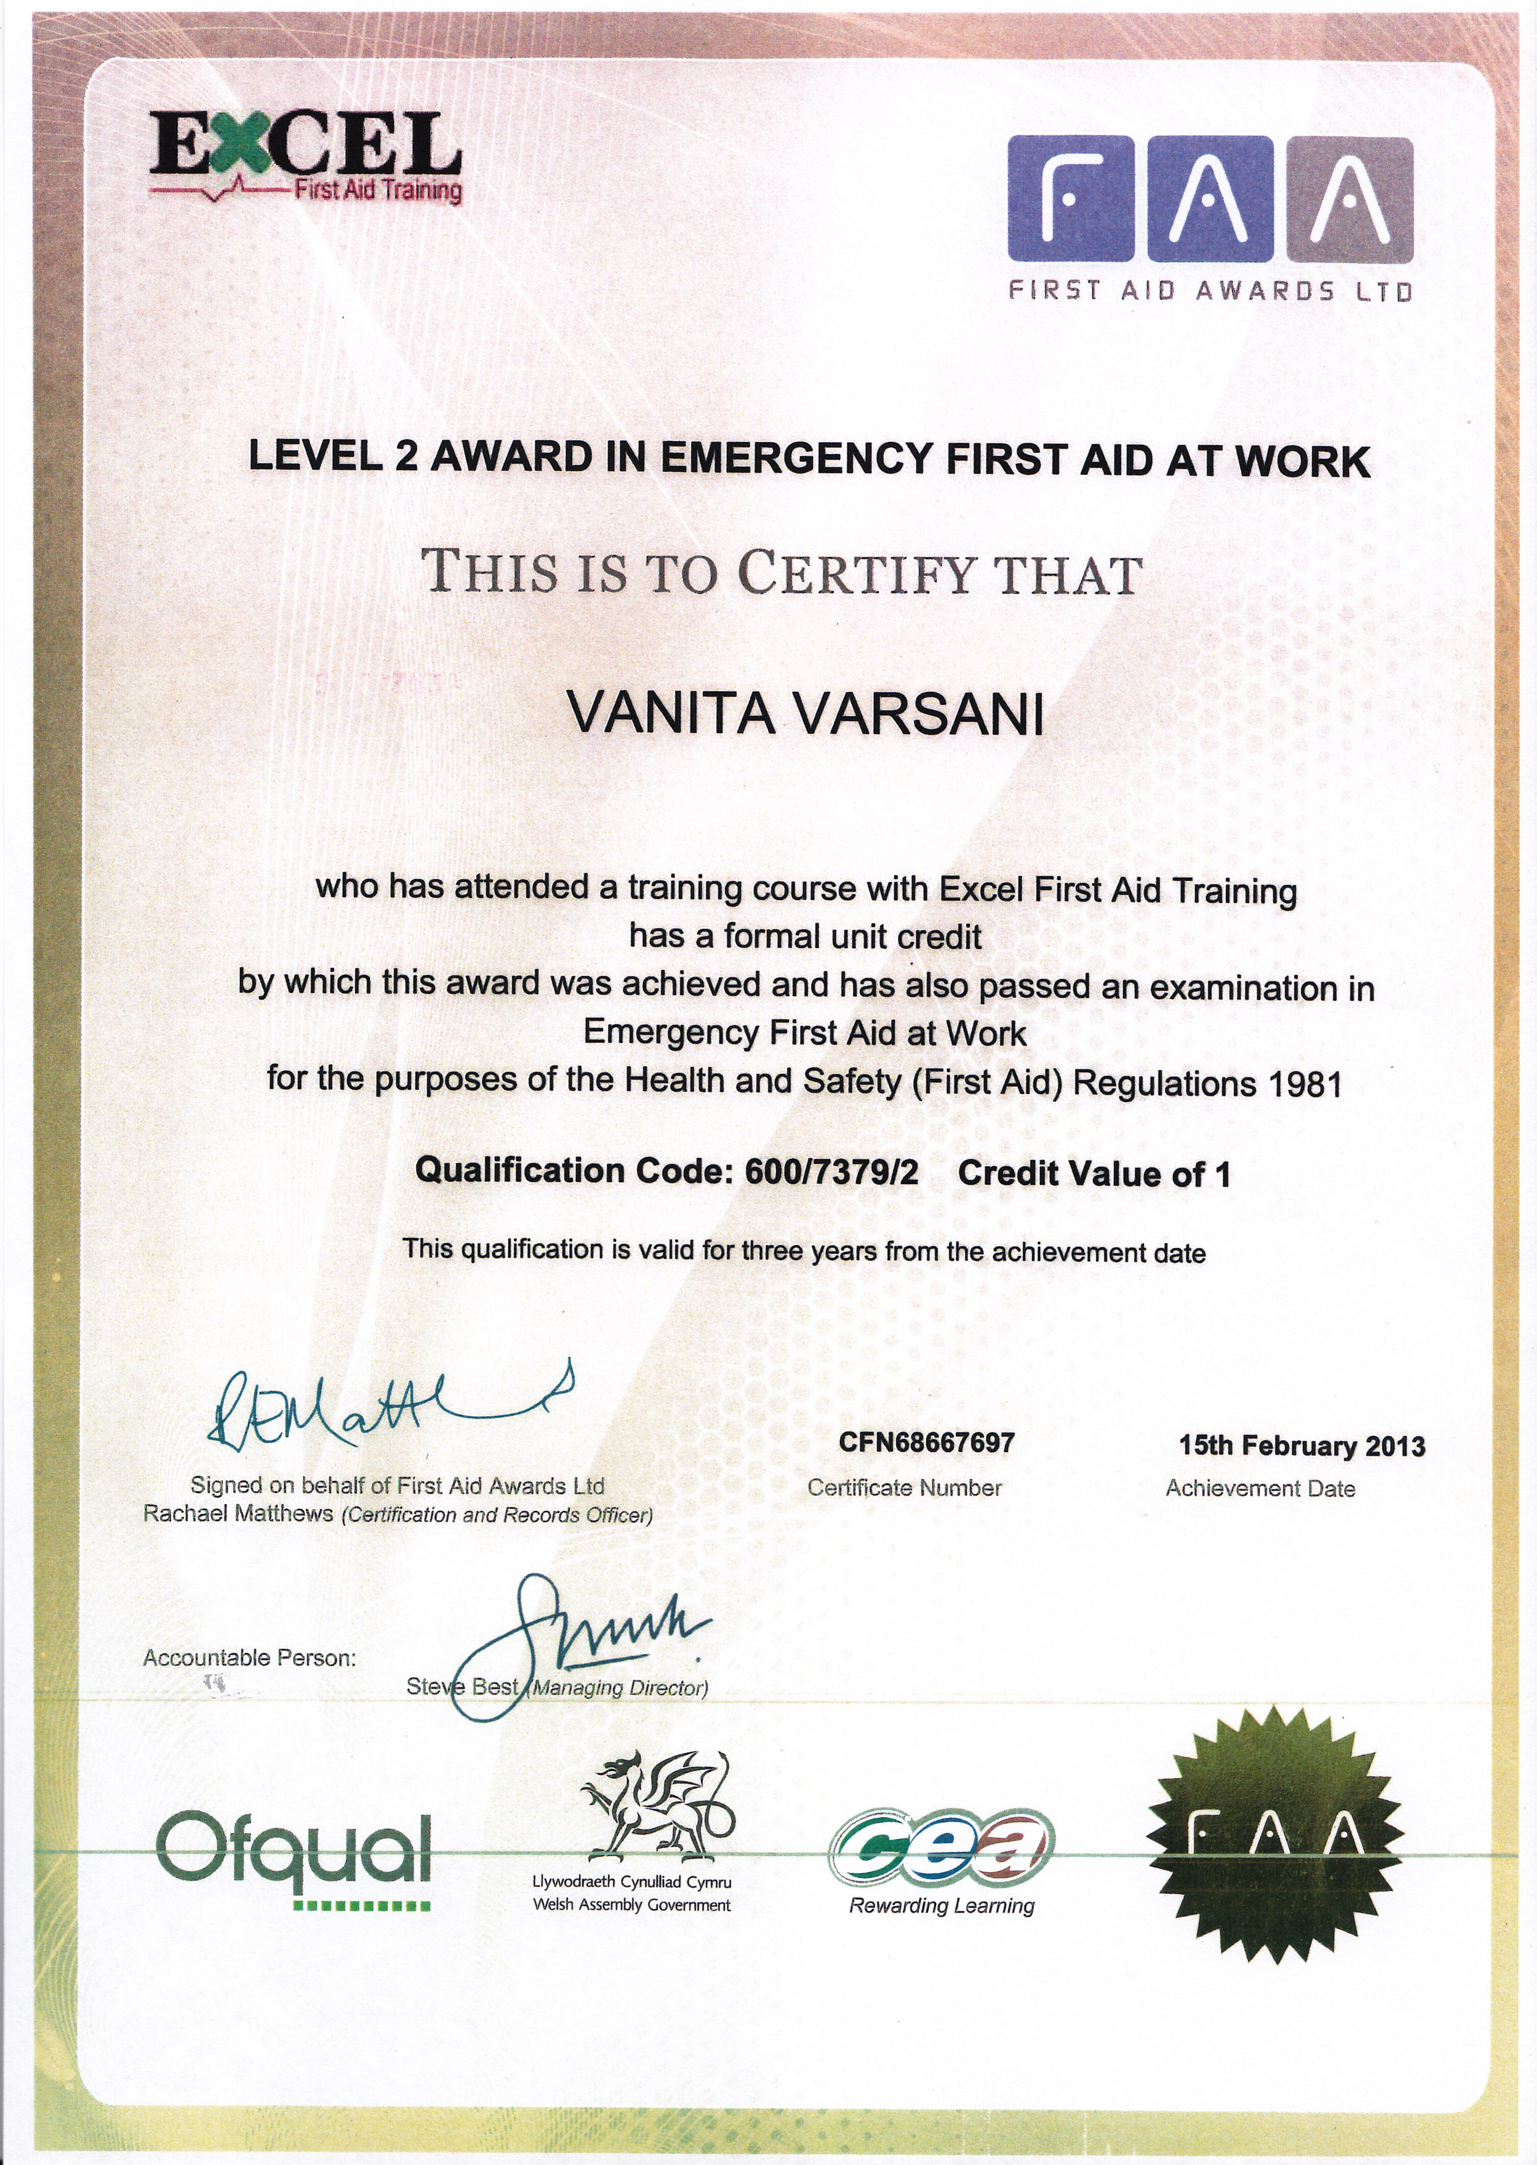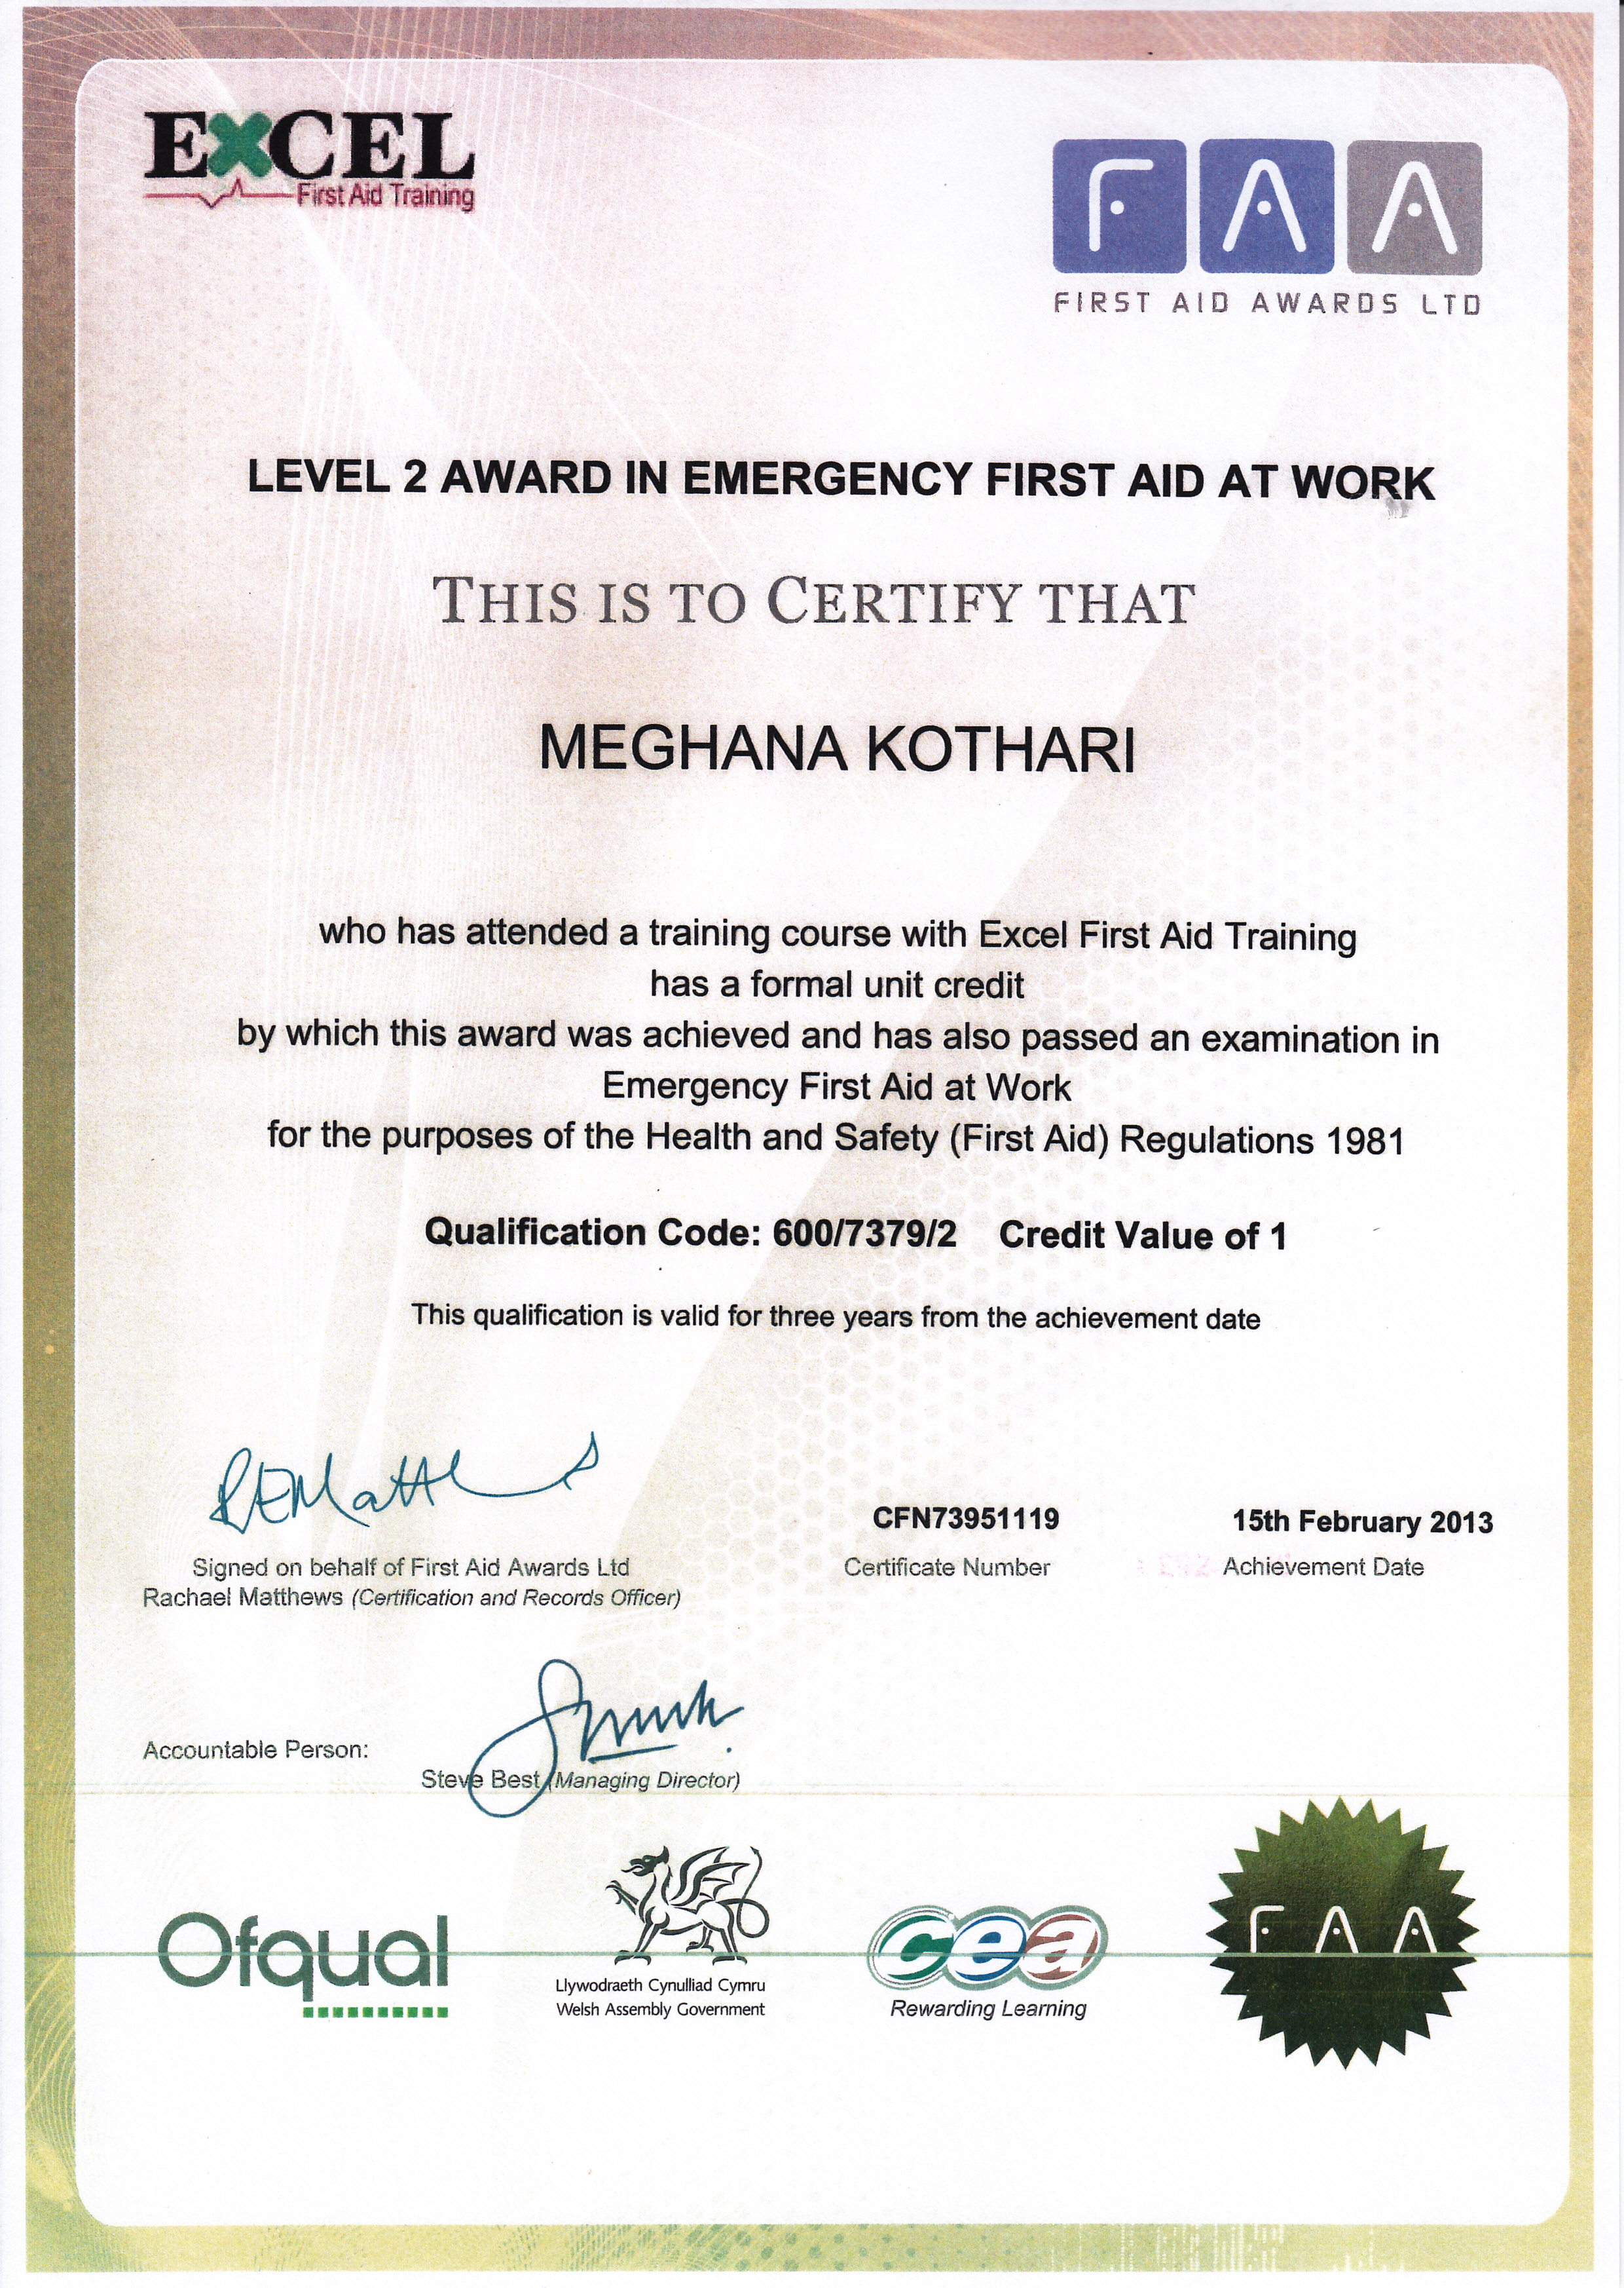

PAT test Certificate.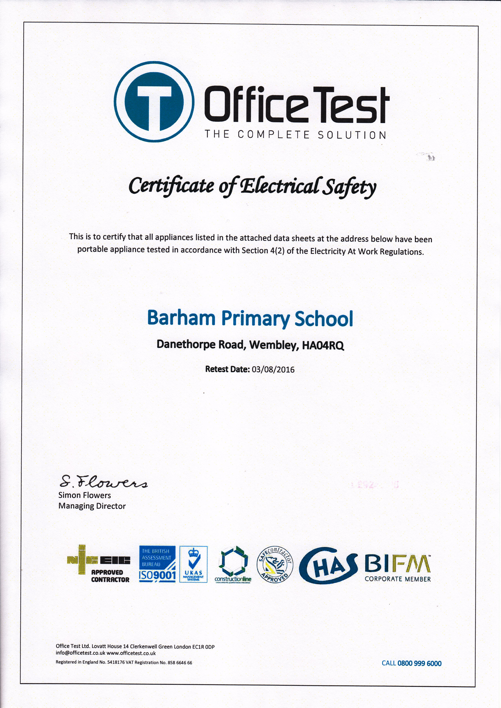

APPENDIX H
Fire extinguishers service Certificate
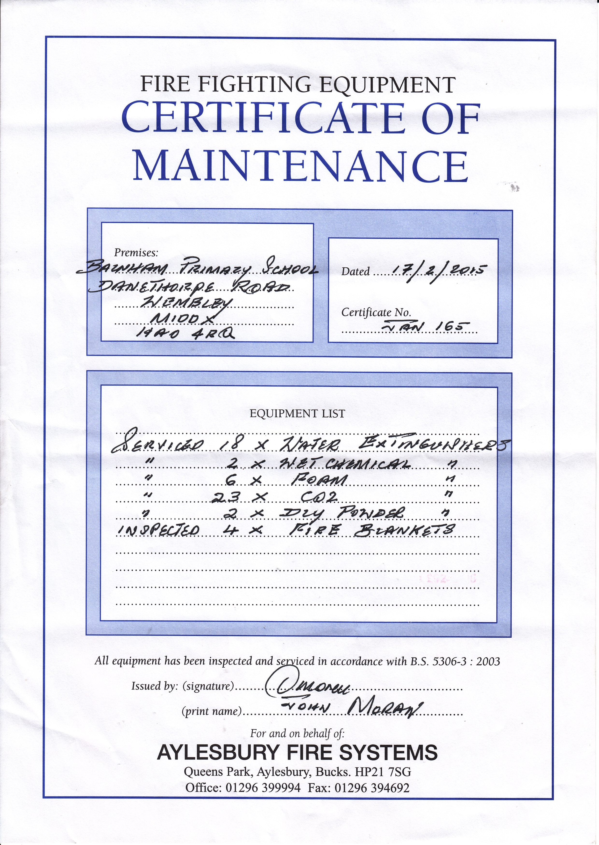

Fire Wardens
Colin Gerald Cleaning Team Exp May 2016
Gidea Heaton Music Department Exp May 2016
Karen Giles Head Teacher Exp May 2016
Lea Murray Teacher Exp May 2016
Louisa Antoni Welfare Officer Exp May 2016
Michael Cleary Year 2 Teacher Exp May 2016
Niru Patel Governor/ Nursery Nurse Exp May 2016
Peter Haines Facilities Manager Exp May 2016
Rimal Jesani Year 3 Teacher Exp May 2016
Shireen Manikam Year 6 Teacher Exp May 2016

