Name: Class:

IMPORTANT KEYBOARD KEYS – What does each Key do?

**Type the answers in the speech bubbles.**

**GP**

Go to this website to help you: **bit.ly/2OkDRK1**

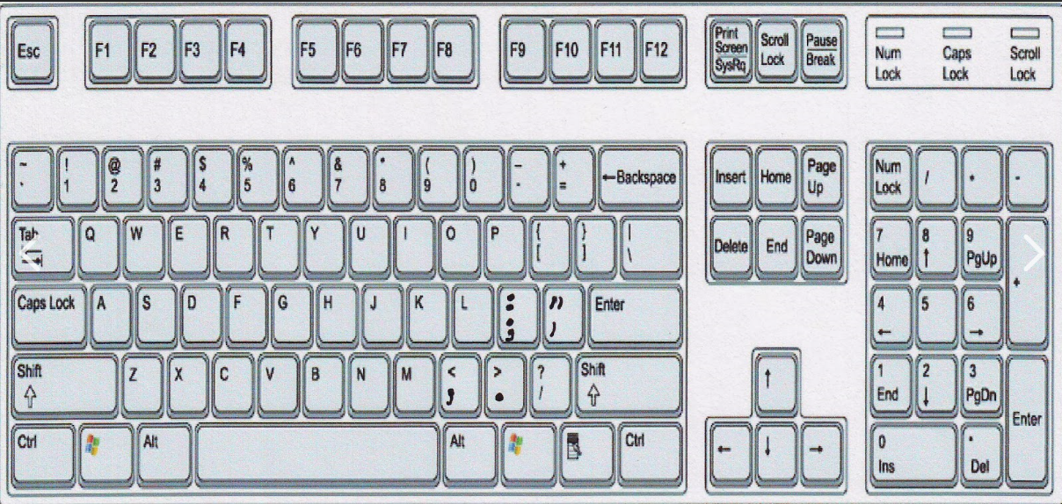

What is this key used for?

What is this key used for?

What is this key used for?

What is this key used for?

What is this key used for?

What is this key used for?